Grades 1-12*
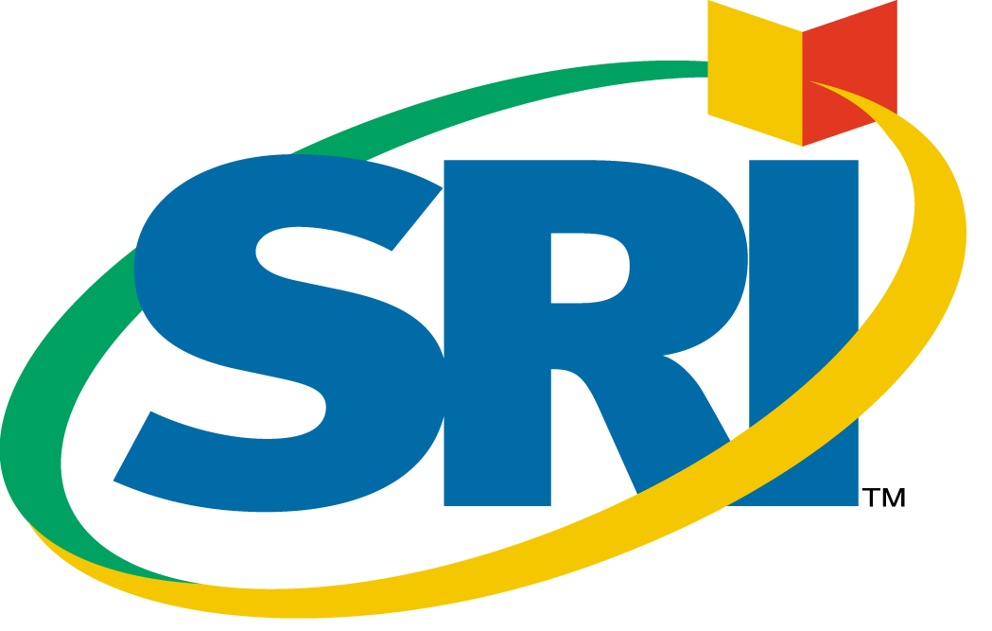

Scholastic Reading Inventory™
Developed in partnership with MetaMetrics, Inc., the creators of the
Lexile Framework® for Reading.

Scholastic Reading Inventory™ (SRI), provides progress monitoring and reading assessment in both interactive (computer-based) and print versions.

Scholastic Reading Inventory: Interactive Version

Version 3.0

Computer-Adaptive Reading Assessment and
Progress Monitoring

Version 3.0 is a new edition of SRI designed to help educators meet the requirements of the No Child Left Behind Act – and make data-driven decisions.
- Monitors progress of ALL students
- Through assessment of reading levels, allows educators to
MEET STUDENT NEEDS (differentiate instruction) and evaluate the effectiveness of curriculum/programs.
- Helps schools and districts DEMONSTRATE ACCOUNTABILITY through the disaggregation of student data, as required by NCLB.
- SRI is the only classroom-based assessment program that directly reports student reading levels using the native Lexile® item format—providing an immediate way to match student to books.

*Kindergarten students can be enrolled in SRI Interactive. However, as SRI is based on text passages, students should at least be at the beginning reader level before they take the test.

SRI and the New Assessment Landscape

“Under this historic law, schools must measure and report on overall student performance and the achievement of various groups of students. With this level of diagnosis and the valuable information state and local leaders, parents and others will soon have, we can all work together to ensure that all students succeed and that the achievement gap is closed, once and for all.”
Rod Paige, U.S. Secretary of Education

The No Child Left Behind Act of 2001 (NCLB) has set a new standard for measuring achievement—one with significant consequences for schools that fail to make progress over time.

NCLB requires:
- Each child and each subgroup of children in Grades 3-8 must have their progress measured and reported annually.
- Reading First Assessment Requirements: Screening, Diagnostic, Progress Monitoring, and Outcome-based
- Progress Reports (individuals, grades, schools, districts)
- Disaggregate student data to demonstrate accountability. All public schools and districts will be held accountable for the achievement of individual subgroups, including students in major racial/ethnic groups, economically disadvantaged students, limited English proficient students, etc.
- Adequate Yearly Progress is the growth needed in the percentage of students achieving proficiency in Reading & Math
  - Each state to set AYP measures and targets
  - Punitive action for schools/districts over 12 year period
  - AYP is the new measure of quality for all public schools

Thus, the need for concrete, reliable information on all students’ reading progress has never been greater. Scholastic Reading Inventory helps schools increase student reading achievement and meet NCLB requirements.

New SRI v3.0 Positioning
• Monitor Yearly Progress
- Track and analyze performance over time
- Help students prepare for high-stakes tests
• Assess Reading Levels
- Match students to text for successful reading
- See range of reading proficiency in every classroom
• Meet Student Needs
- Identify struggling readers
- Plan for instruction and intervention
• Demonstrate Accountability
- Disaggregate student data
- Set measurable objectives for specific sub-groups
How SRI Works:
- Student selects areas of reading interest.
- Student spends approximately 20 minutes taking the test.
- Student receives a personalized reading list based on interests and measured reading level.
- Teachers receive assessment measures and clear, actionable reports.


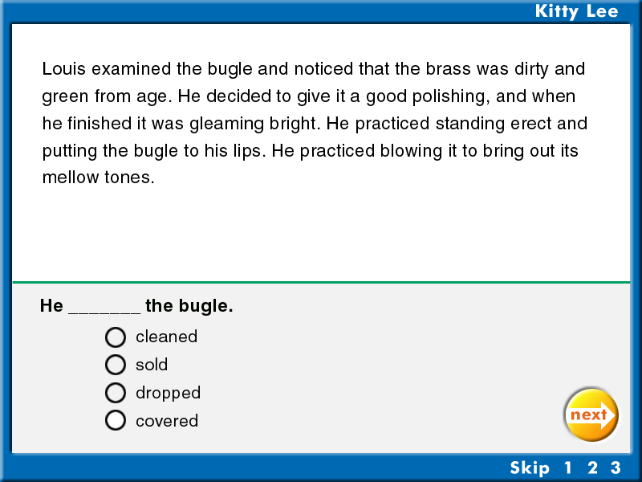
1
2

Book Interest Screen for Grades 3-5. (Not shown: screens for K-2 and 6+)
Test Question (based on authentic text passages)

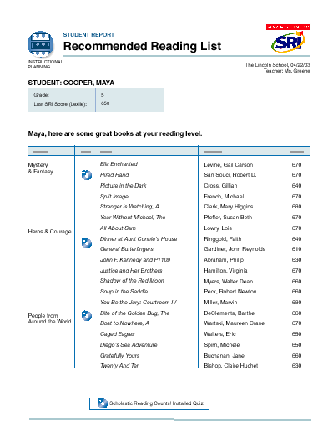
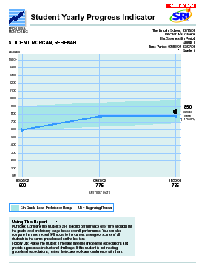
3

4

Personalized Student Reading List
One of 15 customizable reports

SRI: A District-wide

SRI functions as a quick “reading physical” at all stages of a student’s academic career. Educators use SRI to pretest at the beginning of the school year, and test again at intervals throughout the year to measure reading progress and determine student needs.

Elementary:
Identifying problems early is crucial at this stage in the growth of young readers. Using SRI at the critical elementary level can help start students on the path to reading success.

Middle School:
Meeting the diverse needs of middle-school students is a challenge. Administering SRI and making full use of SRI’s comprehensive reports helps educators gauge the effectiveness of their programs and instruction in meeting this challenge.

High School:
The importance of assessment and intervention continues into the high-school years. With SRI, educators can keep on helping older students in their pursuit of academic and life-enhancing reading skills.

SRI Interactive Features—Why it Works
The information educators need to close the achievement gap:
Monitor Reading Progress
SRI tracks individual, group, class, and school-wide progress over time, to help educators identify struggling readers, plan for instruction, gauge the effectiveness of curriculum, and demonstrate accountability.
Assess Reading Comprehension Levels
SRI generates direct and immediate norm-referenced results, including a percentile rank, stanine, NCE score, grade performance standard, as well as the criterion-referenced Lexile® measure for each student. SRI is the only classroom-based assessment program that directly reports student reading levels using the native Lexile item format.
With this data, teachers place students educationally, adjust instruction according to students’ needs, and match readers to text.
Uses Authentic Literature-Based Passages
All 3,000 questions in the SRI item bank are based exclusively on passages from authentic children’s literature, both fiction and non-fiction, as well as excerpts from young adult and classic literature and newspapers, magazines, and periodicals. (Balance of non-fiction to fiction increases with the complexity of the test). SRI tests comprehension of this written literature, not just vocabulary; thus improving the validity of the test results.

Students do not need prior knowledge of the subject or source material of the passages. Students must read and understand each passage in order to answer the associated question correctly. The questions require a command of a variety of reading comprehension skills, including identifying details, paraphrasing information, drawing logical conclusions, making inferences, and making generalizations (although these skills are not reported on specifically).

Computer-Adaptive
SRI uses computer-adaptive technology, meaning that the test automatically self-adjusts as the student answers questions—becoming more difficult when answers are correct, and easier if incorrect. The software adapts in this way until it finds the level at which the student consistently answers each question correctly—resulting in fast, accurate assessment, with no “test burnout” for students!

The software recalls the previous testing situation, so that test items are not duplicated and testing is even faster in subsequent administrations. SRI is used in classrooms and/or a computer lab.

Matches Students to Books
Based on Lexile Framework® for Reading, only SRI gives each student a personalized reading list of books matched to his or her interests and measured Lexile® level. This feature provides an opportunity to support an independent reading program at school or at home. (Take Home Book List accompanies SRI Print - See SRI—Print Version).

Kid-friendly Features
If necessary, students may quit an SRI test before completion and return to the test later where they left off. This allows flexibility to accommodate schedules for computer use, if students simply need more time, or if the testing session must be interrupted for some reason. When they log into SRI again, they will automatically be prompted to continue the test.

In addition, the program can be set to display test questions in large type and test instructions can be read aloud by the computer. An optional practice test given before the actual test helps get students accustomed to the program. Students can also skip up to three questions without it affecting their score, thereby giving them a measure of control over the testing experience.

Flexible and Economical
Administer SRI any time, as needed, at no extra charge. Student licenses can be reassigned at any time (great for transient populations), and are reusable from year to year.

Easy Access to Student Data
The flexible SRI management tools allow for easy customization and instant access to student data. SRI has the same management system as READ 180 and Scholastic Reading Counts!—making it possible for teachers to have one comprehensive database of their students, and one easy system for efficient reading program administration. (SRI--Print Version has management forms.)

Demonstrate Accountability
SRI v3.0 gives educators powerful data export tools to disaggregate student data for the accountability purposes. Easily transfer all your SRI data into a spreadsheet program, such as Excel, for further analysis, to follow NCLB guidelines.

SRI v3.0 allows you to capture and export not only student testing data, but also student classifications and affiliations with various special programs, including programs you add:

Student Classifications
- Gender
- Ethnicity

Program Affiliations
- Bilingual
- Economically Disadvantaged
- ESL
- Gifted and Talented
- Learning Disabled
- Migrant
- Special Education
- Title 1
- Add Program (Option to add programs)

Book Expert™ Database
The powerful book search engine—Book Expert—gives teachers access to over 32,000 titles from over 500 publishers. Part of the management system, Book Expert lets teachers search these titles by criteria such as genre, theme, author, award, Lexile level, Guided Reading level, grade-equivalent reading level, and interest level. With Book Expert, teachers can instantly generate reading lists based on curriculum and the reading needs of their students.

SRI Reports

Immediate, Actionable Data for Schools
The most powerful feature of Scholastic Reading Inventory is its ability to organize and analyze data based on student test results. In a series of 15 powerful reports—generated at the touch of a button—SRI provides concrete, reliable feedback that teachers can share with students, families, and administrators. These clear, understandable reports help educators plan for instruction, identify student needs, and as required by NCLB, monitor yearly reading progress,

SRI v3.0 Reports have specific purposes: Featuring 6 new report categories:

 | Purpose | Audience | Examples
Progress Monitoring  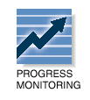 | These reports let teachers and administrators detect trends in reading growth for individuals, groups, and classes. | Teachers will use these reports for ongoing progress monitoring.  Teachers may share reports with students, families, and administrators to set goals and discuss progress, successes, and concerns.  Reports that are best for sharing with students and those in leadership positions are specially labeled. | - Growth Report  - Reading Performance Summary  - Yearly Progress Indicator
Diagnostic   | These reports on strengths and weaknesses in specific areas help teachers differentiate instruction to meet individual needs. | Teachers will use these to determine appropriate courses of action for individual students. | - Student Action Report
Instructional Planning  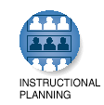 | Instructional Planning reports help teachers plan targeted, data-driven instruction. With these reports, teachers may group students according to their skill needs or according to the activities or texts on which students are working. | Teachers will use these reports as they set up student groups and assign materials. | - Intervention Grouping Report  - Targeted Reading Report
Alerts   | Alerts send a signal that a student requires their attention. | Alerts can be triggered automatically when a teacher logs on to the Scholastic Management Suite. | Incomplete Test Alert
School-to-Home  | These letters, available in English and Spanish, include student-specific progress information as well as home-involvement suggestions. | Families will appreciate these progress reports, which may be sent home or shared during conferences. | - Parent Letter in English  - Parent Letter in Spanish
Management   | Management reports provide lists of enrolled students and all teachers using the Scholastic Management Suite | Teachers and administrators will use these reports to help with record-keeping. | - Student Roster  - Teacher Roster

SRI v3.0 features 15 new and revised reports—

- Growth Report
- NEW! Proficiency Report
- Reading Performance Summary
- Recommended Reading List
- Student Progress Report
- NEW! Student Yearly Progress Indicator
- NEW! Yearly Progress Indicator
- Student Action Report
- NEW! Intervention Grouping Report
- Targeted Reading Report
- Incomplete Test Alert
- Parent Letters (English and Spanish) – Spanish is NEW!
- Student Test Printout
- Student Roster
- Teacher Roster

Key New Reports:

Student Yearly
Progress
Indicator
Monitor students’ progress over time and compare their performance against grade-level proficiency ranges. This reports helps teachers and administrators assess overall performance and identify students not meeting grade-level expectations.

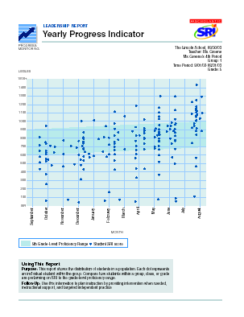
Yearly Progress Indicator
This report shows the distribution of students in a population. Each dot represents an individual student within the group. See how students within a group, class, or grade are performing against their grade-level proficiency range.

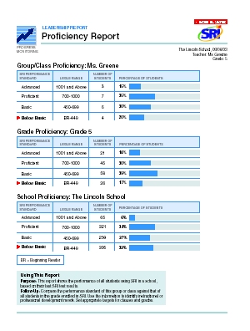
Proficiency Report
Compare the performance standards of a group or class against those of all students in the grade and school to measure progress and set reading achievement goals.

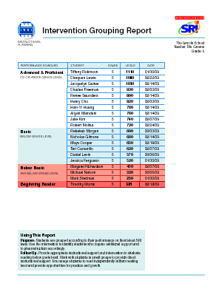
Intervention Grouping Report
Easily group your students for intervention and instructional purposes with this new report, which organizes students into four performance groups: BR (Beginning Reader), Below Basic, Basic, and Advanced & Proficient.

See Report Printouts at the end of this section for full size reports.

COMING SOON!

SRI State Editions
With the increasing demands for accountability and making progress toward proficiency state goals, we are planning to introduce a new concept for SRI called SRI State Editions—SRI v3.0 with reports that show state-specific proficiency cut points and incorporate state-specific language. SRI State Editions will enable customers to see precisely if students are meeting their state’s proficiency standards.

Stay-tuned for more details later in the year.
What’s New in Version 3.0
- 15 new & revised reports designed to help meet the requirements of NCLB.
- Enhanced Data Export capability to disaggregate student data for accountability purposes.
- Enhanced Student Reading Lists, based on triple the database of titles, provides up to 30 titles per student.
- Revised test item database.
- Technical enhancements for greater product stability:
  - Smoother user experience based on enhancements and fixes to SMS code
  - Growth Report revised to show growth between any two tests in any set time period.
  - Negative Lexile scores will now be reported as zero (not negative numbers)
  - Printing issues addressed for all reports

Changes to SRI Educator’s Guide (part of product package) now focused entirely on education, not technology implementation:
- New introduction to Teaching with SRI.
- New explanation of function and importance of the SRI Reports.
- Explicit technical information is a separate component: SRI Installation Guide/Software Manual.

SRI—Print Version

SRI Print Version provides a paper-based alternative to SRI Interactive Version, so that educators can quickly and accurately assess reading comprehension without the need of computer technology. SRI Print Version is available in English and Spanish, and offers two forms for pre- and post-testing.

SRI--Print Version is…
- Manageable. Whole group administered, it’s easy to score and determine results.
- Accurate. Assessment is based on comprehension of authentic literature passages, not just vocabulary! Utilizes the Lexile Framework for Reading.
- Flexible. Results are consistent with results from to widely used standardized tests; assists in both instruction and independent reading.
- Comprehensive. Assesses students reading comprehension in grades 1-12 and may be administered multiple times to track progress and determine growth.

SRI Print Version is a whole-group reading comprehension assessment for Grades 1-12 (Levels 11-18, HS-Alt 1 & 2). This 40-70 item test is available in English and Spanish, in two forms (A & B) for pre- and post-testing. It is packaged in sets of 30, with a Teacher’s Guide and Take-Home Book List.
SRI Print Version connects school to home with at Take-Home Book List affording recommended titles and a letter explaining the importance of daily reading practice. The Teacher’s Guide includes administration and scoring instructions, management forms, and a Lexile Map conversion chart that plots instructional levels.
Assesses Reading Comprehension.
SRI Print Version provides a Lexile measure and correlation to grade level ranges, and norm-referenced data. This information may be used to help teachers place students educationally, adjust instruction according to students’ needs, and match readers to text. It is designed to be used whole-group in classrooms.

Uses Authentic Literature-Based Passages.
SRI Print Version questions are drawn from the 3,000-question item bank of SRI Interactive Version. These questions are based exclusively on passages from authentic children’s, young adult, and classic literature, both fiction and nonfiction, as well as newspapers, magazines, and periodicals. The balance of nonfiction to fiction increases with the testing levels 11-18 (11-15=50%; 16-17= 60%; 18=70%). SRI tests comprehension of written literature, not just vocabulary; thus improving the validity of the test results. A bibliography of literature titles from which each item is taken may be found on the last page of each test level.

Available in Spanish.
SRI Print version is available in Spanish for levels 11-18 (Forms A & B). It is ideal for Bilingual or Foreign Language educators who need to assess reading comprehension in Spanish. A Spanish Lexile Leveled Reading Map, Take-Home Booklist, and Teacher’s Guide come with each level, much like the English version. The Spanish Print version is also used to measure proficiency in Spanish for the purpose of gauging student’s preparedness for learning English.

Utilizes The Lexile Framework® for Reading.
Like SRI Interactive Version, one of the outcomes of SRI Print Version is a Lexile measure, based on the proven, research-based system that accurately matches readers to text. Since thousands of books are also Lexile leveled, you can match students to books with confidence and ease. This score enables the teacher and parent to chart a student’s progress on the Lexile Leveled Reading Map and thereby obtain a picture of that student’s reading as they progress from Grades 1 to College!

Matches students to books.
Over 30,000 titles have been Lexile leveled to date. Scholastic features approximately 3,000 of those in the Supplemental Catalog and 30,000+ in the Reading Counts catalog. From our extensive database, a Take-Home Book List has been created which helps parents select books at their child’s appropriate reading level. The teacher may choose to select Lexile leveled books as a part of students’ instruction or to guide students for independent reading.

Assists in tracking Reading Progress.
Two forms of the test are available so that Form A can serve as a benchmark and Form B as a measure of reading growth. The same form can be administered multiple times per year for a small reuse fee. (Reuse would necessitate use of answer sheets, an additional expense as well). Multiple testing helps teachers track achievement and adjust instruction.

Management for the Educator.
SRI--Print Version is managed by the teacher through the use of management forms found in the Teacher’s Guide.

Packaged for Flexibility
SRI Print Version (English & Spanish) is packaged in sets of 30 for all levels 11-18 and HS Alt-1 or HS Alt-2 in forms A or B. A Teacher’s Guide and Take-Home Book List, as well as a poster of the Lexile Framework accompanies each level. (See below for an explanation of the grade level each test represents.)
Answer-key sheets for hand scoring and Scannable Test Booklets for machine-scoring are available and can be ordered through Jefferson City.

Leveled Assessment
SRI Print Version is leveled appropriately for the developmental level of students in grades 1-12. Levels 11-16 are intended for Grades 1-6 respectively, Level 17 for Grades 7-8, Level 18 for High School. The HS-Alt1 and HS-Alt 2 are high interest, low readability level tests developed exclusively for at-risk students in middle and high school, reading more than 3 grade levels below. The HS Alt-1 assesses students with reading levels from 4th through 6th grade, while the HS Alt-2 assesses students with reading levels from 7th and 8th grade. (See table on next page for suggestions on which test levels school districts should purchase based upon overall student performance)

NOTE: Beginning readers should not be tested until at least mid-year or preferably at year’s end when they are reading and comprehending.

SRI The Basics/SRI--Print Version--Test Selection Chart

Low Performing Schools/Districts

Fall/Spring Administration
Kindergarten | Grade 1 | Grade 2 | Grade 3 | Grade 4 | Grade 5
 | 11 | 11/12 | 12/12 | 13/13 | 14/14
Grade 6 | Middle School  Low | Middle School  Average | High School  Low | Middle School Advanced or High School  Average
15/15 | Alt1/Alt2 | 16/17 | Alt 2/Alt 2 | 17/18

Average Performing Schools/Districts

Fall/Spring Administration
Kindergarten | Grade 1 | Grade 2 | Grade 3 | Grade 4 | Grade 5
None | 11 | 11/12 | 12/13 | 13/14 | 14/15
Grade 6 | Middle School  Low | Middle School  Average | High School Low | Middle School Advanced or High School  Average
15/16 | Alt1/Alt2 | 16/17 | Alt 2/Alt 2 | 18/18

High Performing Schools/Districts

Fall/Spring Administration
Kindergarten | Grade 1 | Grade 2 | Grade 3 | Grade 4 | Grade 5
 | 11 | 12/13 | 13/14 | 14/15 | 15/16
Grade 6 | Middle School  Average | Middle School  Advanced | Middle School -or-  High School  Low | High School  Average
16/17 | 17/17 | 17/18 | HSAlt1 or 2 | 18/18

Frequently Asked Questions

Scholastic Reading Inventory

What is SRI?
SRI offers 1-12 educators a fast, accurate way to assess reading levels, measure yearly progress, and match students to books.

- Measures reading comprehension quickly and accurately.
- Allows educators to measure reading growth throughout the year.
- The only classroom-based assessment program that directly reports student reading levels using the native Lexile® item format.
- Matches students to text (through the Lexile Framework).
- Generates individualized reading list for every student based on interests and reading level.
- Uses text passages from authentic literature to measure comprehension.
- Computer adaptive test: Self-adjusts in response to student’s answers (see below).
- Recalls previous testing sessions.
- Quick results: Test takes approximately 20 minutes.
- Reports progress in Performance Standards—beginning reader, below basic, basic, proficient, and advanced.
- More assessment measurement than any program of its kind. (See below.)
- 15 reports that track students’ reading progress over time.
- Flexible use accommodates specific student needs.
- Interactive Version can be administered as needed, at no additional cost – Student licenses can be reassigned and are reusable from year to year. (Minimal charge for Print Version).
- Features the Scholastic Management Suite™ for teachers—a comprehensive tool that allows for easy organization and access to all student data and connects to other programs such as READ180 and Reading Counts!

What does SRI measure?
SRI determines a student’s reading comprehension level and provides more assessment information than any program of its kind. It is both criterion-referenced and norm-referenced. It has been validated in both digital and print versions. The assessment results produced by SRI are:
- Lexile measure
- Grade Performance Standard
- Percentile Rank
- Stanine
- NCE (Normal Curve Equivalent)

Connects to High-Stakes Tests
Leading test publishers have linked their assessment products to the Lexile Framework. Thus SRI connects classroom-based measurement with standardized testing through the open standard of the Lexile Framework. In this way, SRI gives educators a unique opportunity to bridge the gap between high-stakes assessment and instruction and provides an indication of future performance on such tests. Here are tests that report a Lexile level:

- Harcourt Educational Measurement:
-- Stanford Diagnostic Reading Test: SDRT-4
-- Stanford Achievement Test (versions 9 & 10): SAT-10 and SAT-9
-- Metropolitan Achievement Test (8th Edition): MAT-8
- CTB/McGraw-Hill:
-- TerraNova Assessment Series (CAT/6 and CTBS/5).
- The Riverside Publishing Company:
-- GMRT-4 (Gates-MacGinitie Reading Test)
- Northwest Evaluation Associates:
-- NWEA Achievement Level Tests in print and electronic versions. Minnesota is one state that uses the NWEA.
- The Iowa Tests:
-- ITBS and ITED.

The Lexile Framework has also been linked to several state assessments, including:
- North Carolina End-of-Grade Tests
- Utah Core Assessment Tests, their state-level criterion-referenced test.

Additionally, states and districts throughout the U.S. utilize Lexiles as a critical part of the reading curriculum, including:
- Alabama
- California
- Florida
- Hawaii
- Idaho
- New Mexico
- North Carolina
- Texas
- Utah
- Wyoming

What is the relationship between Lexiles and SRI?
SRI is the only classroom-based assessment program that directly reports student reading levels using the native Lexile® item format. The SRI and the Lexile Framework for Reading work together to accurately assess reading levels and match students to books. The Lexile Framework uses a single measure – a Lexile – to evaluate both the level of the reader and the level of the text. By placing both reader and text on the same scale, the Lexile Framework provides an effective match between the two. SRI is the only classroom-based assessment program that directly provides a Lexile measure for every student. Thus, SRI enables teachers to select books that will optimize reading development for students of all abilities. In addition, scores from SRI can be utilized to plan for instruction. They may serve as placement tools for other Scholastic programs like READ 180 and Read XL. SRI results may also be used by teachers to set goals and benchmarks that track student progress.

What is a “computer-adaptive” test?
SRI utilizes computer-adaptive technology. As a student takes the test, the software automatically monitors the response to every question. If the student misses a question, the next question will be slightly easier. If the student answers correctly, the next question will be slightly harder. Therefore, the computer “adapts” to the student’s ability, adjusting the difficulty level of each question until an accurate score is achieved.

How is SRI packaged?
Unlike the Print Version, SRI Interactive Version is NOT packaged by grade level or form. SRI Interactive Version contains a database of over 3,000 questions from which students, grades 1-12, can be tested and re-tested. Therefore, one product covers all grade levels. However, the customer will need to choose between the Stand-alone or Network version of the product. The CD-ROM is a hybrid disc serving both Macintosh and Windows computers. The package includes: the program on one CD-ROM, Educator’s Guide, Installation Guide/Software Manual, a Technical Guide, a quick reference card, and a poster-size Lexile map. (The Technical Guide provides information on the development of SRI, its technical characteristics—both validity and reliability—and the scores students receive from the test.) Customers also receive one year of toll-free telephone technical support.

How does it work?
With SRI Interactive Version, students receive a score in approximately 20 minutes:
- Student logs on and enters their secure password.
- Student selects areas of reading interest.
- Teacher can determine if student needs to take a practice test.
- Student spends approximately 20 minutes on the computer taking the test.
- Student receives individualized reading list, based on interests, developmental level, and their measured reading level (Lexile measure).
- Teacher receives Lexile measure, grade performance level and normed percentile measures, as well as clear, actionable reports that may be used to plan for instructional and intervention.

What Types of Reports Are Available?
SRI has 15 reports. See earlier description and examples at end of this section.

What is the research and validation behind SRI?
The SRI Technical Guide describes how SRI was developed—its technical characteristics, both validity and reliability and the scores that students receive from SRI. This 22-page guide comes with the product and can be ordered as a sales tool for serious prospects (See Sales Tools Section). Also, a copy is included in the Research & Validation Section of this binder, along with faxable documents on SRI’s validation. SRI Print research and validation is outlined in a book for sale separately called “SRI Technical Manual.” (It is also available on a limited basis as a sales tool.)

What grade levels does SRI cover?
SRI Interactive Version is recommended for students grades 1 through grade 12. While kindergarten and first grade students can be enrolled in SRI Interactive, we recommend they should take the test only if they are reading. Since SRI measures reading comprehension, even a first grader may not be ready to take this test by mid- to end-of-year. In many cases, first graders are not comprehending fully when they read. They are developing their decoding skills and reading fluency, but often cannot handle reading passages of 4-5 sentences in length and answering higher order thinking questions about those passages.

What type of computers do customers need?
SRI will run on both Macintosh and Windows computers, both networked and stand-alone computers. SRI Print Version should be used in those schools/districts who do not have the available technology to run SRI Interactive Version, or combine the two versions, Print and Interactive, in districts where there is unequal distribution of technology. See Packages & Pricing section for recommended SRI Interactive system requirements.

Who is the Competition?
SRI’s main competition is the STAR Reading® (computer-based) test from Renaissance Learning, Inc., the makers of Accelerated Reader®. The main weakness of STAR is that it is mainly a “vocabulary” test, relying mostly single “fill-in-the-blank” sentences, with only 5 text passage questions per test. STAR doesn’t match students to text, nor does it produce an individualized reading list for students. It does not share management with its sister product, Accelerated Reader. (See section on Competition for further information.)

DRP (Degrees of Reading Power) is the main print-only competitor for SRI Print Version. It utilizes similar cloze passages as SRI, however, they are not of authentic literature and are not considered higher-order thinking by customers who have evaluated the test. Customers also report that the test isn’t as visually appealing as SRI. The test reports out in a double-digit metric (DRP) which customers say is too tight for flexibility for the student (difference between 2 grade levels is often only 1 DRP).

